Project Management Skills
Project management is a very important field that has a big impact on companies' performance in different sectors. The core of good management includes key project management skills that help managers deal with complicated problems, guide their teams, and achieve the goals they set out to reach.

While knowing what project management is and its purpose works as the foundation, a detailed knowledge of advanced project management skills is essential to entering the space.

In this detailed guide, we will explore the key skills required for effective project management and look at the main abilities a capable project manager must cultivate for impactful results!

What Are Project Management Skills?
Project management skills refer to a collection of skills required to manage a project efficiently. Often acquired through specialised programs or years of experience, project management skills can help to accomplish a project easily. This includes hard skills like technical things you can measure, as well as soft skills related to working with people and how one behaves. The project manager needs to get better at combining these two kinds of abilities to make any project successful.

Project Management Hard Skills
Project management hard skills involve technical abilities like making project plans, arranging schedules, managing budgets, handling risks, implementing Agile methodology, managing resources and being skilled in using project management software.

Project Management Soft Skills
Soft skills required for project managers are personal and behavioural abilities that allow project managers to lead well and work together with the people involved. These abilities cover effective communication, guiding a group, finding solutions for issues, making choices and understanding emotions.

30 Project Management Skills Every Project Manager Should Have
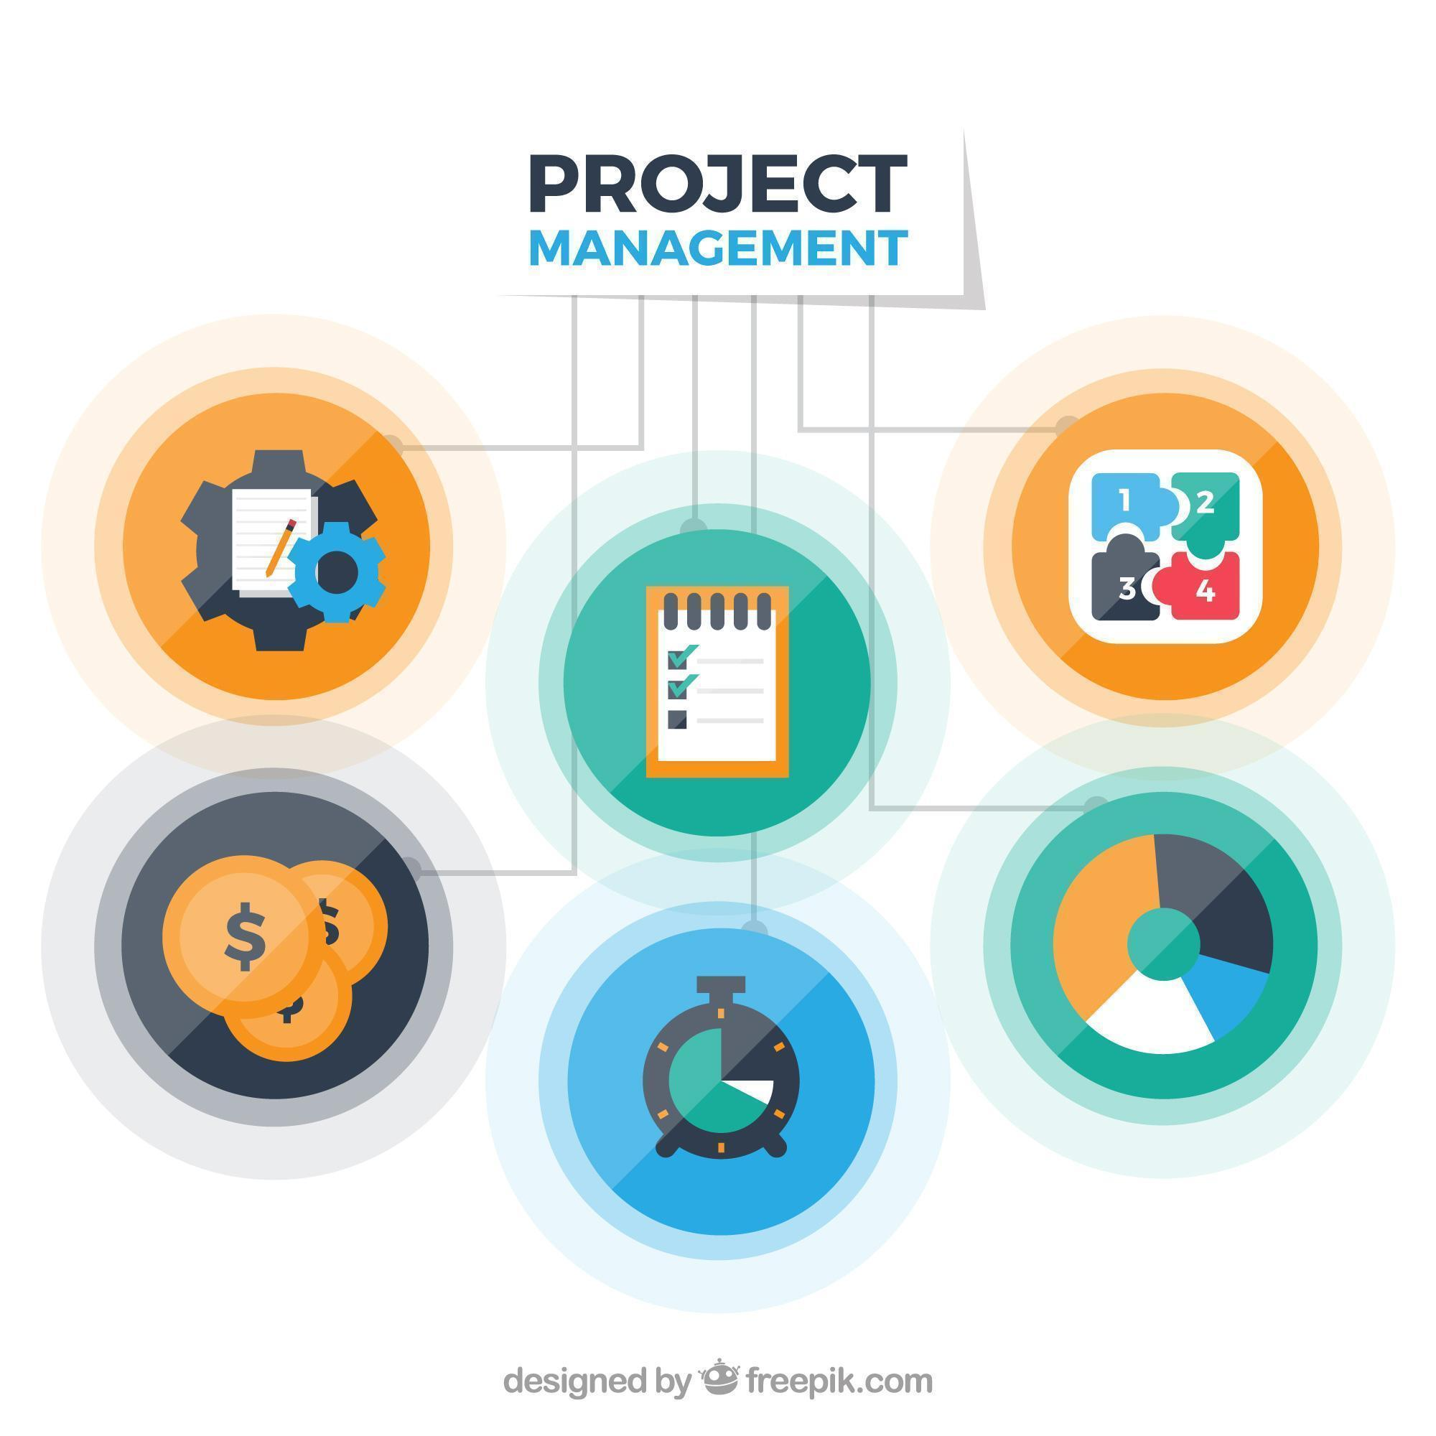
Diverse project management skills

To do well as a project manager, one needs a wide and diverse range of project manager skill sets. This includes striking the right balance between technical and behavioural abilities. To help you set yourself in the right direction, we have curated a list of technical and soft skills needed for project management.

There are 30 important skills for managing projects that all project managers should work on improving:

1. Knowledge of Project Management Methodologies
Having a good grasp of different project management methods, such as Agile, Scrum, Waterfall, and Lean, is very important for adjusting to various project needs and organisational environments.

2. Proficient With Project Management Software
Knowing how to use project management software like Microsoft Project, Jira, Asana, and Trello is very important for good planning, monitoring and working together on projects. Having these project management tools in your inventory makes sure your work processes are streamlined and on track.

3. Project Planning
Making detailed plans for projects, which include deciding on the project boundaries, goals, what will be delivered, and key progress points, is an essential ability for project managers. This is also where you can leverage your knowledge of project management software to align tasks easily.

4. Project Scheduling
Project timetable is good when you make tasks small, guess how long they take and plan well so the finish time is as expected. Being good with your time is all you need to excel in your projects and claim more satisfied clients.

5. Project Scoping
Setting and controlling project boundaries is necessary to avoid unexpected work growth and keep the project on track with its goals. This is one of the most critical skills project managers must have on their resumes.

6. Project Forecasting
Project managers need to have the ability to predict project expenses, what resources they will require, and possible risks so that they can make wise choices and distribute their resources in a good way.

7. Project Tracking
Consistent project tracking and monitoring are important aspects to notice when projects are not following the plan. This allows us to take steps to fix this and ensure the projects stay on course. Potential mishaps and skipping deadlines are less likely to happen with consistent project tracking.

8. Project Reporting
Project reporting skills that are clear and straight to the point are very important for sharing information about project development, problems faced, and successes with those involved and working on the team.

9. Project Budgeting
To manage a project's budget well, you need to calculate the expected costs, decide how to distribute resources and take care of the money so that the project finishes without spending too much.

10. Team Management
Team management

Effective team management skills, such as creating strong teams, inspiring members, and solving disputes, are essential to creating an environment that promotes teamwork and project productivity.

11. Workload Management
Project managers need to manage the work well, assign tasks based on what team members can do and when they are free, and ensure that everyone has a fair amount of work.

12. Time Management
Good time management skills, such as choosing what is most important, delegating tasks to others, and using project management tools well, are necessary to finish project work on time.

13. Risk Management
Project managers must be skilled at finding, evaluating, and reducing project risks to address possible problems early on and ensure the project's success.

14. Cost Management
Skills in managing costs include monitoring project spending, handling budgets well, and implementing steps to control expenses to improve the project's financial success. Cost management can contribute to the overall growth of an organisation.

15. Task Management
Managing tasks well, like dividing up the work for a project, giving people specific jobs to do and keeping an eye on how things are moving forward, is really important for making sure that the project moves along without problems.

16. Leadership Skills
Good leadership abilities are very important for a project's success. For example, you must be able to motivate your team, create a happy work environment, and show them the right way by doing it yourself.

17. Communication Skills
Good speaking and writing skills are important for clearly sharing details, goals, and news about the project with those involved and the people working on it.

18. Negotiation Skills
Project managers need good negotiation abilities to solve disagreements, obtain the necessary resources, and reach agreements with various stakeholders.

19. Organisational Skills
Efficient project management requires good organizational skills, such as managing documents, arranging files properly, and keeping the project workspace well-ordered.

20. Interpersonal Skills
Interpersonal skills

Skills like understanding others' feelings, listening well, and creating good relationships are important for the team to work well together and for successful cooperation with the people involved.

21. Problem-Solving Skills
Project managers need to have good skills for solving problems. They must find and fix issues that come up while doing the project, making sure solutions are provided quickly and work well.

22. Adaptability
Project managers must be able to adjust to project needs, market situations, and what the organisation sees as important change. This is key for handling shifting projects.

23. Decision-Making Skills
Project managers need to make smart choices by examining data, evaluating risks, and listening to stakeholders. It is very important for them to make decisions well and with a strategy at hand.

24. Attention to Detail
Project managers must pay careful attention to details. This is important for making sure that the work is accurate, of high quality, and meets project rules and standards.

25. Critical Thinking
Project managers use their critical thinking abilities to understand complicated scenarios, weigh different choices, and decide wisely in a way that matches the goals of their projects.

26. A Sense of Humour
Having a sense of humour is useful for project managers because it can make relationships with team members better, calm down stressful moments, and contribute to a happy environment in the project.

27. Patience
Patience is an important ability for project leaders to deal with difficulties, control what stakeholders anticipate, and steer through the complexities of projects while remaining calm.

28. Personal Appearance
Project managers must keep a professional look and behave well to build trust and give confidence to those involved in the project, like stakeholders and team members.

29. Delegation
Project managers who are good at delegating can give tasks to team members according to what they do best. This can help the team members feel more responsible for their own work.

30. Collaboration
Project managers must have good skills in collaboration to help the team work as one, share what they know, and use everyone's strengths. Collaborative abilities ensure the project displays a certain degree of cohesion, which is necessary for it to have the right impact.

How to Develop Your Project Management Skills
To enhance project management skills, you must keep learning and practising regularly with strong commitment. Some methods to get better at project management include:

- Study for formal qualifications and get certifications like the PMP certification to build a strong base in project management.

- Acquire hands-on knowledge by assuming roles in project coordination at your workplace or offering to help with initiatives in the local area.

- Attend workshops, webinars, and meetings to stay current with new trends, instruments, and methods in project management.

- Become a member of expert groups in project management, such as PMI (Project Management Institute), to connect with peers, exchange understanding, and receive wisdom from skilled professionals.

- Look for experienced project managers to guide, advise, and help you during your professional growth.

- Always think about your project management past work, see where you can get better, and make sure to improve your abilities by learning on your own and practising.

To improve your project management skills, consider looking at insightful material. For example, if you wish to enhance your foundational knowledge, check out Project Management Tutorial. This can give you useful information, practical advice, and the best methods used in the industry so you can be better at your job as a project manager.

Conclusion
Project management skills are essential for successfully completing challenging tasks. By learning both technical and interpersonal skills, project managers can handle the complicated situations that arise within projects, guide their teams to reach the project goals, and benefit their companies. If you want to be a project manager or improve what you already know, it is good to put effort into learning more about managing projects.

Keep in mind that improving skills for managing projects is a continuous process. As you keep learning, use what you know and look for opportunities to grow.

Check out the Project Management Masters Program offered by Edureka to kickstart your learning journey today!

Frequently Asked Questions

What are project management skills?
Project management skills include a combination of technical capabilities and the skill to interact well with others, allowing project managers to plan, carry out, and oversee projects with full efficiency.

What are the three most important skills of a project manager?
The significance of skills in managing projects can differ based on the project itself and the organisation. Still, three critical abilities for those who manage projects include good communication, strong leadership, and problem-solving skills.

What are the four basics of project management?
Four main parts of managing a project, include- Scope, Time, Cost and Quality

Is project management a hard skill?
Project management involves a mix of technical abilities and interpersonal skills, which can be pretty challenging for many people. However, people with natural leadership abilities can easily navigate this role with full responsibility.

- What are the three major challenges in project management?

The three major challenges in project management are:
- Internal team conflict
- Monitoring and planning problems
- Project scoping and estimation issues

